**SUPER RESOLUTION USING DEEP LEARNING**

**A PROJECT REPORT**

*Submitted by*

**Harshal Patel (150280116034)**

**Jaimin Goswami(150280116024)**

*In fulfilment for the award of the degree*

*Of*

**BACHELOR OF ENGINEERING**

*In*

INFORMATION TECHNOLOGY



**L.D College of Engineering, Ahmedabad**

**Gujarat Technological University, Ahmedabad**

INFORMATION TECHNOLOGY

2018-19

**Date:**

**CERTIFICATE**

**This is to certify that the Project entitled “super resolution using deep learning” has been carried out by HARSHAL PATEL(150280116034) under my guidance in fulfilment of the degree of Bachelor of Engineering in IT ENGINEERING (8th Semester) of Gujarat**

**Technological University, Ahmedabad during the academic year 2018-19.**

**Internal Guide:**

**Mrs. Mittal Panchal**

**Professor of IT Department**

Mrs. Hiteshi Diwanji

Head of Department

Department Of IT Engg.

**L.D College of Engineering, Ahmedabad**

**CERTIFICATE**

**This is to certify that the Project entitled “super resolution using deep learning” has been carried out by JAIMIN GOSWAMI(150280116024) under my guidance in fulfilment of the degree of Bachelor of Engineering in IT ENGINEERING (8th Semester) of Gujarat**

**Technological University, Ahmedabad during the academic year 2018-19.**

**Internal Guide:**

**Mrs. Mittal Panchal**

**Professor of IT Department**

Mrs. Hiteshi Diwanji

Head of Department

Department Of IT Engg.

**L.D College of Engineering, Ahmedabad**

**ACKNOWLEDGEMENT**

We wish to express our heartfelt appreciation to all those who have contributed to this project, both explicitly and implicitly, without the co-operation of whom, it would not have been possible to complete this project.

We would like to thank our H.O.D Mrs. Hiteshi Diwanji and Mrs. Mittal Panchal (Internal Guide) for constantly guiding and showing us the correct path to reach towards our desired goal. Also I thank them for sharing their experience, knowledge and valuable time with me and showing their concern in my project to make it better.

I also thank all the other faculties who directly or indirectly supported me in making my project successful by sharing their ideas and knowledge.

At last, I would like to thank our parents and friends who have directly or indirectly helped us in making the project work successful.

**NAME: SIGNATURE:**

**Harshal Patel(150280116034)**

**Jaimin Goswami (150280116024)**

**INDEX**

|  |  |  |
| --- | --- | --- |
| **Chapter No.** | **Contents** | **Page No.** |
|  | Certificate | II |
|  | GTU Completion Certificate (7th & 8th Sem) | III |
|  | Acknowledgement | Iv |
|  | Index | V |
|  | List Of Figure | ix |
|  | Abstract | xi |
| **1.** | **Introduction** |  |
|  | 1.1 Project Detail | 01 |
|  | 1.2 Project purpose | 02 |
|  | 1.3 Project Scope | 02 |
|  | 1.3.1 Project Features | 02 |
|  | 1.4 Technology and Literature Review | 02 |
|  | 1.4.1 Technology Review(python) | 02 |
| **2.** | **Project Management** |  |
|  | 2.1 Feasibility Study | 07 |
|  | 2.1.1 Operational Feasibility Study | 07 |
|  | 2.1.2 Technical Feasibility | 08 |
|  | 2.1.3 Time Schedule Feasibility | 08 |
|  | 2.1.4 Economical Feasibility | 08 |
|  | 2.1.5 Implementation Feasibility | 09 |
|  | 2.2 Project Planning | 10 |
|  | 2.2.1 Project Development Approach and Justification | 11 |
|  | 2.2.2 Project Plan | 15 |
|  | 2.2.3 Milestones and Deliverable | 15 |
|  | 2.2.4 Group Dependencies | 16 |

|  |  |  |
| --- | --- | --- |
|  | 2.3 Project Scheduling | 17 |
| **3** | **System Requirement Study** |  |
|  | 3.1 Study of Current System | 18 |
|  | 3.2 Problem and Weakness of Current System | 18 |
|  | 3.3 Hardware and Software Requirement | 19 |
|  | 3.4 Constraints | 19 |
|  | 3.4.1 Regulatory Policies | 19 |
| **4** | **Requirement of Proposed System** |  |
|  | 4.1 Main Module of the System | 20 |
|  | 4.1.1 Introduction | 20 |
|  | 4.2 Features of New System | 21 |
| **5** | **System Analysis** |  |
|  | 5.1 System Architecture Design | 23 |
|  | 5.1.1 Use-case Diagram | 24 |
|  | 5.1.2 Data Flow Diagram | 24 |
|  | 5.1.3 System architecture Diagram | 25 |

|  |  |  |
| --- | --- | --- |
| **6** | **Implementation Planning** |  |
|  | 6.1 Implementation Environment | 28 |
|  | 6.1.1 Implementation Planning | 29 |
|  | 6.2 Coding Standards | 32 |
|  | 6.2.1 Purpose of coding Standards and Best Practices | 32 |
|  | 6.2.2 Naming Convention and Standards | 33 |
| **7** | **Testing** |  |
|  | 7.1 Testing | 38 |
|  | 7.2 Testing Plan | 39 |
|  | 7.2.1 Testing Strategy | 42 |
|  | 7.3 Testing Methods | 43 |
|  | 7.3.1 Statistical Testing | 43 |
|  | 7.3.2 Defect Testing | 44 |
| **8** | **Conclusion and Reference** |  |
|  | 8.1 Conclusion | 46 |
|  | 8.2 Reference | 46 |
|  | **Appendix- I : Periodic Progress Report ( 1 to 4)** |  |
|  | **Appendix- II : PSAR Report** |  |
|  | **Appendix – III : Patent Drafting Exercise** |  |
|  | **Appendix- IV : Plagiarism Report** |  |
|  | **Appendix- V : Design Engineering Canvas** |  |

**LIST OF FIGURES**

|  |  |  |
| --- | --- | --- |
| **Figure No** | **Figure Description** | **Page No** |
| Figure 2.2.1 | Agile Life Cycle | 11 |
| Figure 2.2.4 | Team Structure Of Group | 17 |
| Figure 5.1.1(a) | Use case diagram | 27 |
| Figure 5.1.4.1 | Data Flow diagram | 34 |
| Figure 5.1.5.2 | System architecture diagram | 38 |
| Figure 7.1 | Testing Process | 59 |

**CHAPTER-1 INTRODUCTION**

**Abstract :**

**Single Image Super Resolution involves increasing the size of a small image while keeping the attendant drop in quality to a minimum. The task has numerous applications, including in satellite and aerial imaging analysis, medical image processing, compressed image/video enhancement and many more.**

## 1.1 PROJECT DETAILS:

Our objective is to take a low resolution image and produce an estimate of a corresponding high‑resolution image. This problem is ill‑posed – multiple high‑resolution images can be produced from the same low‑resolution image. For instance, suppose we have a 2×2 pixels sub‑image containing a small vertical or horizontal bar [Fig. 1]. Regardless of the orientation of the bar, these 4 pixels will correspond to just one pixel in a picture downscaled 4 times. With real life images, one needs to overcome an abundance of similar problems, making the task difficult to solve.



**Figure 1:** from left to right, ground truth HR image, corresponding LR image,

prediction of a model trained to minimize MSE loss. First, let’s introduce a quantitative quality‑measurement method to evaluate and compare the models. For each model implemented, we will compute a metric commonly used to measure the quality of reconstruction of lossy compression codecs, called Peak Signal to Noise Ratio (PSNR). This metric is a de‑facto standard used in Super Resolution research. It measures how much the distorted image (possibly of lower quality) deviates from the original high‑quality image. In this setting, PSNR is the ratio of maximum possible pixel value of the image (signal strength) to maximum mean squared error (MSE) between the original image and its estimated version (noise strength), expressed in logarithmic scale.

The larger the PSNR values, the better the reconstruction, and therefore maximization of PSNR naturally leads to minimizing MSE as the objective function. That was our approach in two out of three models we present here in our experiments, we trained the models to upscale input images four times (in terms of width and height). Above this factor, upscaling even small images becomes hard – for example, an image upscaled eight times has a 64x bigger pixel count. Storing it consequently requires 64x more memory in raw form, to which it is converted during training.

## Why deep learning?

One of the most commonly used techniques for upscaling an image is interpolation. Although simple to implement, this method leaves much to be desired in terms of visual quality, as the details (e.g. sharp edges) are often not preserved.

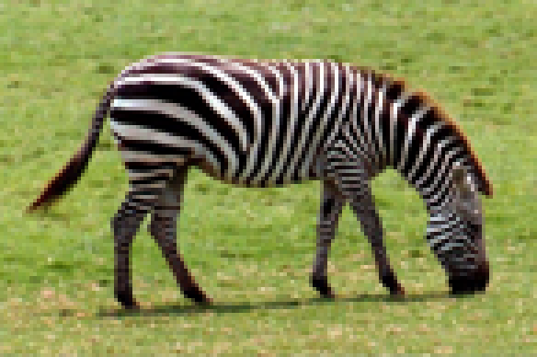

(nearest neighbour interpolation) (bilinear interpolation)



(bicubic interpolation)

**Figure 2:**

 Most common interpolation methods produce blurry images. From top to bottom:  
nearest neighbour interpolation, bilinear interpolation and bicubic interpolation. The image  
was up scaled 4x.

More sophisticated methods exploit internal similarities of a given image or use datasets of low‑resolution images and their high‑resolution counterparts, effectively learning a mapping between them. Among example‑based SR algorithms, the sparse‑coding‑based method is one of the most popular.

This method requires a dictionary to be found that will allow us to map low resolution images into an intermediate, sparse representation. In addition, the HR dictionary is learned, and will allow us to restore our estimate of a high resolution image. Such a pipeline usually involves several steps and not all of them can be optimized. Ideally we would like to have all of these steps combined in one big step with all of its parts being optimizable. That effect can be achieved by a neural network, the architecture of which is inspired by sparse coding.

## 1.2 PROJECT PURPOSE

The purpose of this document is to estimate a high-resolution version of the visual data using a training dataset and reference dataset. A set of training data is generated and a generator convolutional neural network parameterized by first weights and biases is trained by comparing characteristics of the training data to characteristics of the reference dataset.

## 1.3 PROJECT SCOPE

This can be used in any online application that uses sending and receiving of image. So, we can send image by lossy compression technique and re estimate it by this project. We can also use it in astronomy applications to enlarge image size.

### **1.3.1 PROJECT FEATURES**

This application will provide following features

* Estimation of pixels
* Regeneration of original image from lossy compressed one

## 1.4 TECHNOLOGY AND LITERATURE REVIEW

### **1.4.1 Technology Review(Python):**

**What is Python for deep learning?**

Deep learning is the most interesting and powerful machine learning technique right now. Top deep learning libraries are available on the Python ecosystem like Theano and TensorFlow. Tap into their power in a few lines of code using Keras, the best-of-breed applied deep learning library.

**TensorFlow:**

TensorFlow is an open-source software library for dataflow programming across a range of tasks. It is a symbolic math library, and is also used for machine learning applications such as neural networks. It is used for both research and production at Google, often replacing its closed-source predecessor, DistBelief. TensorFlow was developed by the Google Brain team for internal Google use. It was released under the Apache 2.0 open source license on November 9, 2015.

**Keras:**

Keras is an open source neural network library written in Python. It is capable of running on top of TensorFlow, Microsoft Cognitive Toolkit, Theano, or MXNet. Designed to enable fast experimentation with deep neural networks, it focuses on being user-friendly, modular, and extensible. It was developed as part of the research effort of project ONEIROS, and its primary author and maintainer is François Chollet, a Google engineer

# CHAPTER-2 PROJECT MANAGEMENT

## 2.1 FEASIBILITY STUDY

Feasibility is a practical extent to which a project can be performed successfully. To evaluate feasibility, a feasibility study is performed, which determines whether the solution considered to accomplish the requirements is practical and workable in the software or not. Such information as resource availability, cost estimate for software development, benefits of the software to organization, and cost to be incurred on its maintenance are considered. The objective of the feasibility study is to establish the reasons for developing software that is acceptable to users and adaptable to change.

A feasibility study is a short, focused study, which aims to answer a number of questions:

* Does the system contribute to the overall objectives of the organization?
* Can the system be implemented using current technology and within given cost and schedule constraints?
* Can the system be integrated with systems which are already in place?
* Operational Feasibility
* Technical Feasibility
* Scheduling Feasibility
* Economic Feasibility
* Implementation Feasibility

Now each of them is explained briefly, as below.

### 2.1.1 OPERATIONAL FEASIBILITY STUDY

The main purpose of checking Operational Feasibility is to find out whether the system will be functional after its development and installation or not. The outcomes of the operational feasibility are as follows:

* In this application user can create a group and manage the members of the group
* User can track the position of another members
* It eliminate the limitation of existing system
* Hence this application is operationally feasible.

### 2.1.2 TECHNICAL FEASIBILITY

The main purpose of checking Technical Feasibility is to examine whether the current technology is sufficient for the development of the system. The outcomes of the technical feasibility are as follows:

* Tool to announce arrival uses android studio as programming platform, My SQL in back end.

* The application is developed in Android studio can be run on any android phone which is running on kit Kat (API 19) or later.
* For back end we have used My SQL server for data connection.
* It provides faster response to its users. It is accurate, reliable and easy to use.
* Hence this application is technically feasible.

### 2.1.3 TIME SCHEDULE FEASIBILITY

A project will fail if it takes too long to be completed before it is useful. Typically, this means estimating how long the system will take to develop, and if it can be completed in a given time period using some methods like payback period. Given our technical expertise, are the project deadlines reasonable? Some projects are initiated with specific deadlines. You need to determine whether the deadlines are mandatory or desirable.

### 2.1.4 ECONOMICAL FEASIBILITY

Economic analysis could also be referred to as cost/benefit analysis. It is the most frequently used method for evaluating the effectiveness of a new system. In economic analysis the procedure is to determine the benefits and savings that are expected from a candidate system and compare them with costs. If the expected benefits equal or exceed costs, the system can be judged to be economically feasible. Economic analysis is used for evaluating the effectiveness of the proposed system.

The economic feasibility will review the expected costs to see if they are in-line with the projected budget or if the project has an acceptable return on investment. At this point, the projected costs will only be a rough estimate. A rough estimate of the project schedule is required to determine if it would be feasible to complete the systems project within a required timeframe. The required timeframe would need to be set by the organization.

### 2.1.5 IMPLEMENTATION FEASIBILITY

The main purpose of checking Operational Feasibility is to find out whether the system will be functional after its development and installation or not. The outcomes of the operational feasibility are as follows:

* Service Provider website helps the user for getting information about new available
* Service product quickly by presenting the data in proper format online. Graphical representation of data helps the user in taking proper decision in time. • So, it is supposed to improve the working efficiency of user. • So, this application is operationally feasible.

## 2.2 PROJECT PLANNING

Project Planning is an aspect of Project Management that focuses a lot on Project Integration. The project plan reflects the current status of all project activities and is used to monitor and control the project.

The Project Planning tasks ensure that various elements of the Project are coordinated and therefore guide the project execution. Project Planning helps in

* Monitoring/measuring the project progress, and
* Facilitating communication
* Provides overall documentation of assumptions/planning decisions

The Project Planning Phases can be broadly classified as follows:

* Development of the Project Plan
* Execution of the Project Plan

### 2.2.1 PROJECT DEVELOPMENT APPROACH AND JUSTIFICATION

**Agile Software Development:**

Agility refers to the quality of being agile. Internet software industry and Mobile and wireless application development industry are looking for a very good approach of software development. Conventional software development methods have completely closed the requirements process before analysis and design process. As this approach is not always feasible and compatible with all others projects. In contrast to the conventional approaches, agile methods allow developers to make late changes in the requirement specification document.

The focus of the Agile software development as given by “Agile Software Development Manifesto” is presented in the following: Individuals and interactions over processes and tools Working software over comprehensive documentation.

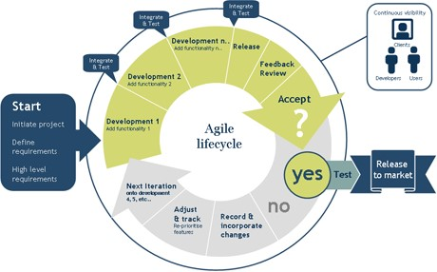

**Agile methods**

Agile methods are designed to produce the first delivery in weeks, to achieve and early win and rapid feedback. These methods invent simple answers so that change can be less.

These also improve design issues and quality as they are based on iteratively incremental method.

* What makes a method an Agile? When the process are:
  1. Incremental: Small releases with rapid iterations
  2. Cooperative: Customer and developer relationships
  3. Straight: The method which is easy to learn and modify with documentation
  4. Adaptive: Able to embrace changes instantly
* Different Agile Software Development methods
  1. Extreme programming
  2. Scrum
  3. Feature driven development

The life cycle of Extreme programming consists of five phases

* 1. Exploration
  2. Planning
  3. Iteration on releases
  4. Product ionizing
  5. Maintenance
  6. Death

Extreme programming is a light weight software methodology for a small to medium sized teams developing software in the rapidly changing requirements situation. XP matches the behaviour of successful programmers in the wild

* Tests
* Refactoring
* Evolutionary delivery
* Incremental planning
* Less overhead

**Scrum**

The term “SCRUM ‟originally derives from a strategy in the game of rugby where it denotes “getting an out of play ball back into the game” with teamwork. Scrum concentrates on how the team members should function in order to produce the system flexibly in a constantly changing environment. Scrum is extremely simple model used bydifferent software companies from long time, which works with existing engineering practices and is scalable and work with common sense which is to say it is very easy.

Scrum process includes three phases

* 1. Pre-game
  2. Development
  3. Post-game

**1. Pre-game phase includes two sub-phases**

Planning and Architecture design

* Planning phase: includes the development of the required system. A Backlog list is created, which contains all the requirements that are known at that moment. In every iteration the Back log list is updated by scrum team to gain commitment for the next iteration.
* Architecture phase: In this phase an abstract view of the model is designed by viewing Backlog list.

**2. The Development phase:**

This phase takes care of the different variable like time frame, quality, requirements, recourses, technologies and tools. Sprints are the iterative cycles where functionality is developed or enhanced to produce new increments. Each Sprint includes the traditional phases of software engineering.

* Requirement
* Analyses
* Designs
* Evolution and delivery

**3. The Post-game phase close to release**.

* Roles in Scrum
* SCRUM master
* Product owner
* Scrum Team
* Customer

Feature Driven Development

FDD is agile approach for software development systems. It provides enough structure for large items, emphasis on quality and working software, delivers frequent, tangible results.

Five phases of FDD

* Develop a overall model
* Build a features list
* Plan by feature
* Design by feature
* Build by feature

**Conclusions**

As we came to know that traditional software development approaches are more mechanistic which concentrate more on Processes, tools, contracts and plans. In contrast to traditional methods, agile methods keep emphasis on interaction, working software, embracing change at any moment of the project, customer relationships. The method can be agile if it is:

* Incremental
* Cooperative
* Straightforward

“Agile view is more people centric rather than plan-centric.”

Agile methods are not defined by a small set of principles, practices and techniques. It creates a strategic capability which has capability of responding to change, capability to balance the structure and flexibility, capability of innovation and creations through development team and uncertainty.

* Scrum
* FDD (Feature driven development)
* DSDM (Dynamic systems development method)

### 2.2.2 PROJECT PLAN

Project planning is basically concerned with identifying and measuring activities, milestones and deliverables produced by project. Thus in this section I cover following: -

Estimating some basic attributes of the project

1. Duration: How long will it take to complete the development?

The project that we have taken contains functionalities which are very complex for an undergraduate. We need to do a detailed research of what combination of technologies would be best for the project, get acclimatized to them, do the rest of the planning and go ahead with the work. Hence the duration of the Project can be roughly estimated to 10 months.

1. Efforts: How much efforts would be required?

Since it is a two people group and as it is a very hazy picture ahead of how to go about the project, figuring that out and considering the pros and cons would take up a lot of effort in itself. Thus efforts can be estimated to 3 hours of weekdays work for 10 months

### 2.2.3 MILESTONES AND DELIVERABLES

Management needs information. As software is intangible, this information can only be provided as documents that describe the state of the software being developed. Without this information, it is impossible to judge progress and cost estimates and schedules cannot be updated. When planning a project series of milestones are established.

|  |  |  |  |
| --- | --- | --- | --- |
| **Sr. No** |  | **Activities** | **Date** |
| 1. | Study of available system |  | 20-07-2018 |
| 2. | Prior tools study |  | 27-07-2018 |
| 3. | Project Synopsis |  | 27-07-2018 |
| 4. | Requirement Gathering |  | 27-07-2018 |
| 5. | Analysis Iteration-1 |  | 04-08-2018 |
| 6. | Analysis Iteration-2 |  | 04-08-2018 |
| 7. | Prototype | | 07-08-2018 |
| 8. | Data Set | | 10-08-2018 |
| 9. | UML Diagrams | | 07-09-2018 |
| 10. | Designing | | 02-10-2018 |

The team members are responsible for all documentation to be developed and for all work to be done. I am grateful to my team member for her dedication in our project development; without her it would be tough for me to even take up this project. For better development of a project, internal and external helped me.

### 2.2.4 GROUP DEPENDENCIES

As I have described there are two members in my team including me, so there has is group dependency.

Team structure is as follows :



Internal Guide

Mrs.Mittal

Panchal

Ka. Patel Harshal

(150280116034)

Goswami Jaimin

(150280116024)

## 2.3 PROJECT SCHEDULING

Scheduling of a software project does not differ greatly from scheduling of any multitask engineering effort. Therefore, generalized project scheduling tools and techniques can be applied with little modification to software projects.

Project scheduling consists of identifying the tasks needed to complete the project, determine the dependency tasks, among different plan the starting and ending dates for various tasks and determine the chain of tasks that determine the duration of the project.

# **CHAPTER-3 SYSTEM REQUIREMENT STUDY**

## 3.1 STUDY OF CURRENT SYSTEM

Currently there are various methods available for zooming

**NEAREST NEIGHBOR INTERPOLATION**

Nearest neighbour is the most basic and requires the least processing time of all the interpolation algorithms because it only considers one pixel — the closest one to the interpolated point. This has the effect of simply making each pixel bigger.

**BILINEAR INTERPOLATION**

Bilinear interpolation considers the closest 2x2 neighborhood of known pixel values surrounding the unknown pixel. It then takes a weighted average of these 4 pixels to arrive at its final interpolated value. This results in much smoother looking images than nearest neighbor.The diagram to the left is for a case when all known pixel distances are equal, so the interpolated value is simply their sum divided by four.

**BICUBIC INTERPOLATION**

Bicubic goes one step beyond bilinear by considering the closest 4x4 neighborhood of known pixels — for a total of 16 pixels. Since these are at various distances from the unknown pixel, closer pixels are given a higher weighting in the calculation. Bicubic produces noticeably sharper images than the previous two methods, and is perhaps the ideal combination of processing time and output quality. For this reason it is a standard in many image editing programs (including Adobe Photoshop), printer drivers and in-camera interpolation.

## 3.2 PROBLEMAND WEAKNESSOF CURRENT SYSTEM

Currently available all methods have many disadvantages like,image got zoomed but the output is very blurry. And as the zooming factor increased, the image got more and more blurred. That would eventually result in fully blurred image. In techniques like zero order hold,  it can only run on the power of 2.

## 3.3 HARDWARE AND SOFTWARE REQUIREMENTS

**Hardware Requirement**

* Minimum 1 GHz processor ARMv7
* Any operating system (most preferable Ubuntu)
* Minimum 4 GB RAM
* Minimum 5 GB Internal storage space

**Software Requirement**

* Python 2.7 or later
* Pycharm
* Machine Learning Libraries(Tensor Flow, Keras)

## 3.4 CONSTRAINTS

### 3.4.1 INTERFACES TO OTHER APPLICATIONS

The application can be used in day to day life used as a intermediatory module for any application that contains networking part of a image.

### 3.4.2 REQUIREMENT OF PROPOSED SYSTEM

In traditional zooming systems if we zoom image then it got blurred, and in networking we need to send image with more bytes in order to send high quality image. But, by this system we can send image by lossy compression technique and send it to destination and recover at destination.

# CHAPTER-4 SYSTEM DESIGN

## 4.1 SYSTEM ARCHITECTURE DESIGN

### **4.1.1 USE CASE DIGRAM**

The Use case diagram is used to define the core elements and processes that make up a system. The key elements are termed as "actors" and the processes are called "Use Cases." The Use case diagram shows which actors interact with each use case.

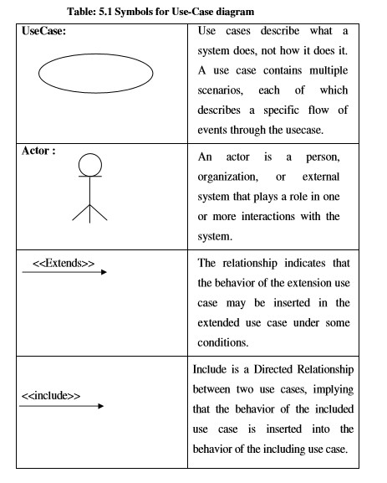

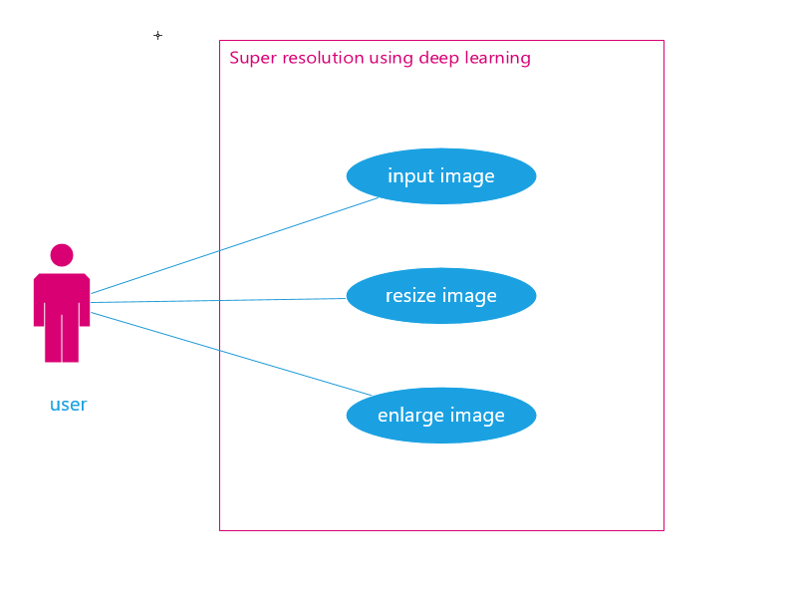

(use case diagram)

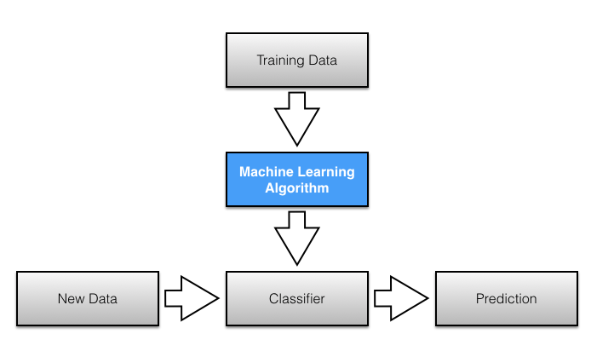

(basic flow diagram of machine learning algorithm)

## 4.1.2 SYSTEM ARCHITECTURE DIAGRAM

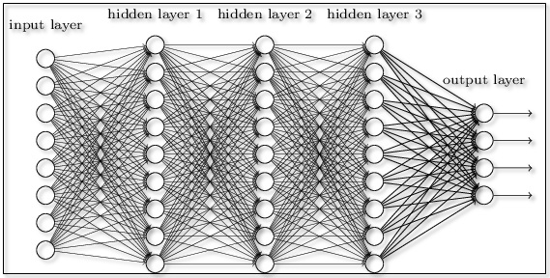

(neural network architecture)

# CHAPTER-5 IMPLEMENTATION PLANNING

## 5.1 IMPLEMENTATION ENVIRONMENT

The Project was a result of a single consensus .The team was having two member. The team structure depends on the management style of the organization, the number of people in the team, their skill levels and the problem difficulty.

### **5.1.1 IMPLEMENTATION PLANNING**

Implementation phase requires precise planning and monitoring mechanism in order to ensure schedule and completeness. We developed the software in various sub phases in Implementation Phase.

## 5.2 CODING STANDARDS

### **5.2.1 PURPOSE OF CODING STANDARDS AND BEST PRACTICES**

Best practices are a set of informal rules that the software development community has learned over time to improve the quality of applications and simplify their maintenance. They can be broken into many levels based on the coding language, the platform, the target environment and so forth. Usingbest practicesfor a given situation greatly reduces the probability of introducing errors into your applications[,](http://en.wikipedia.org/wiki/Application_software) regardless of which [software development](http://en.wikipedia.org/wiki/Software_development) model is being used to create that application.

There are coding standards that originated from the intensive study of industry experts who analysed how bugs were generated when code was written and correlated these bugs to specific coding practices. They took these correlations between bugs and coding practices and came up with a set of rules that when used prevented coding errors from occurring. These standard practices offer incredible value to software development organizations because they are pre-packaged automated error prevention practices; they close the feedback loop between a bug and what must be done to prevent that bug from recurring.

Best practices gives you a way to analyse your source code so that certain rules and patterns can be detected automatically and that the knowledge obtained through previous years of experience by industry experts is implemented in an appropriate way.

### **5.2.2 NAMING CONVENTION AND STANDARDS**

The terms Pascal Casing and Camel Casing are used throughout this document.

**PASCAL CASING:-**First character of all words are Upper Case and other characters are lower case.

Example: Back Color

**CAMEL CASING: -** First character of all words, except the first word is Upper Case and other characters are lower case.

Example: back Color

1. User Pascal Casing for Class names public class Hello World

…..

…..

1. Use Camel Casing for method names

Void say Hello (string name)

……

……

1. Use Camel Casing for variable names int total Count=0;
2. Use the prefix “I” with Camel casing for interface (Example: IEntity).
3. Use Meaningful, descriptive words to name variables. Do not use Abbreviations.

**Good:**

string address Int salary **Not Good:**

stringaddr install

1. Do not use single character variable name like i, n, s etc. use name like index, temp.
2. One exception in this case would be variables used for iterations in loops:
3. If the variable is used only as a counter for iteration and is not used anywhere else in the loop, may people still like to use a single char variable (i) instead of inventing a different suitable name.
4. All member variables must be prefixed with underscore (_) so that they can be identified from other local variables.
5. Do not use variable names that resemble keywords.
6. Prefix boolean variables, properties and methods with “is” or similar prefixes. Example: private bool _is Finished
7. File name should match with class name.

Use Pascal Case for file names.

## Exception Handling

* Never do a 'catch exception and do nothing'. If you hide an exception, you will never know if the exception happened or not. Lot of developers uses this handy method to ignore non significant errors. You should always try to avoid exceptions by checking all the error conditions programmatically. In any case, catching an exception and doing nothing is not allowed. In the worst case, you should log the exception and proceed.
* In case of exceptions, give a friendly message to the user, but log the actual error with all possible details about the error, including the time it occurred, method and class name etc.

Always catch only the specific exception, not generic exception

**Exception Names :**

Because exceptions should be classes, the class naming convention applies here. However, you should use the suffix "Error" on your exception names (if the exception actually is an error).

**Global Variable Names :**

(Let's hope that these variables are meant for use inside one module only.) The conventions are about the same as those for functions. Modules that are designed for use via from M import * should use the __all__ mechanism to prevent exporting globals, or use the older convention of prefixing such globals with an underscore (which you might want to do to indicate these globals are "module non-public").

# **CHAPTER-6 TESTING**

## 6.1 TESTING

Testing is a process of executing a program with the intent of finding an error. If testing is conducted successfully, it will uncover the error in the software.

Secondly, testing demonstrates that software functions appear to be working according to specification and that performance requirements appear to have been met. In additional, data collected as testing is conducted provides a good indication of software reliability and some indication of software quality as whole. But there is one thing that testing cannot do: Testing cannot show the absence of defects, it can only show that software errors are present.

There are several objectives which are as follows:

* Testing is a process of executing a program with the intent of finding an error.
* A good test case is one that has a probability of finding an as undiscovered error.
* A successful test is one that uncovers an as yet undiscovered error.

### Testing Principle

Following are the testing principles which are used:

* All tests should be traceable to customer requirement.
* Tests should be planned long before testing begins.
* Testing should be in small and progress toward testing in the large.
* Exhaustive testing is not possible.
* To be most effective testing should be conduct by independent third party.

## 6.2 TESTING PLAN

The aim of the testing process is to identify all defects existing in software Product. However for most practical systems, even after satisfactorily carrying out the testing phase, it is not possible to guarantee that the software is error free. This is because of the fact that the input data domain of most software products is very large. It is not practical to test the software exhaustively with respect to each value that the input data may assume. Even with this practical limitation of the testing process, the importance of testing should not be underestimated. It must be remembered that testing does expose many defects existing in a Software product. Thus testing provides a practical way of reducing defects in a System and increasing the users’ confidence in a developed system.

### **Functional Testing**

The testing technique that is going to be used in the project is black box testing. In black box testing the expected inputs to the system are applied and only the outputs are checked.

The working or the other parameters of the functionality are not reviewed or tested on the black box testing technique. There is a specific set of inputs for each and every module which is applied and for each set of inputs the result or the output is verified and if found as per the system working this testing is termed or result is declared as pass.

If the set of inputs that are provided to each module are not giving the outputs as per the expected results from the module then the result of that testing is to be declare failed. Moreover the bottom up integration of the modules is applied herein so that each module can be verified at the initial stage and if it is found that the independent module is perfectly alright, only then it is going to be integrated with other related modules otherwise the module is checked for flaws and then if it satisfies all the specific requirements of the module, is integrated to other related modules to form and incorporate a system.

In the black-box testing approach, test cases are designed using only the functional specification of the software, i.e. without any knowledge of the internal structure of the software. For this reason, black-box testing is known as functional testing.

### **Equivalence Class Partitioning**

In this approach, the domain of input values to a program is partitioned into a set of equivalence classes. This partitioning is done such that the behavior of the program is similar for every input data belonging to the same equivalence class. The main idea behind defining the equivalence classes is that testing the code with any one value belonging to an equivalence class is as good as testing the software with any other value belonging to that equivalence class. Equivalence classes for software can be designed by examining the input data and output data.

### **Boundary Value Analysis**

A type of programming error frequently occurs at the boundaries of different equivalence classes of inputs. The reason behind such errors might purely be due to psychological factors. Programmers often fail to see the special processing required by the input values that lie at the boundary of the different equivalence classes. For example, programmers may improperly use < instead of <=, or conversely <= for <. Boundary value analysis leads to selection of test cases at the boundaries of the different equivalence classes.

### **Structural Testing**

In the white-box testing approach, designing test cases requires thorough knowledge about the internal structure of software, and therefore the white-box testing is called structural testing.

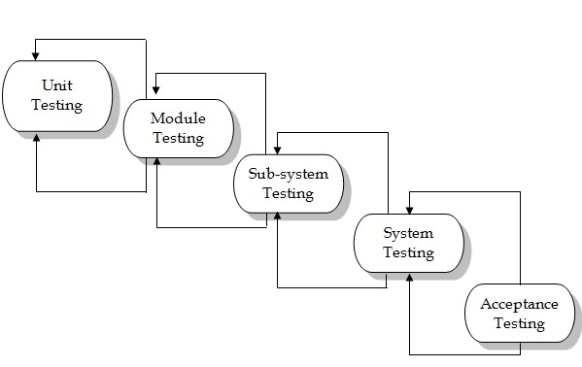

**Fig:-7.1 Testing Process.**

## 6.2 TESTING STRATEGY

The black box testing is going to be used for the project. The entire module is going to be checked for the specific inputs and the output is going to be checked. We are going to test the modules individually and thereafter if found to be working as per the expectations they are going to be integrated with other successfully tested modules and then on integrated.

At last all the modules are integrated and thereafter it is checked on a broader basis and all the requirements which are specified are checked for each integrated system modules. If all the functionalities are successfully satisfied than the entire integrated system is found to be working perfectly alright.

The integration is going to be in a bottom up manner where in each individual modules are going to be checked for the first time initially. Later on as and when other modules are developed and are in a working condition than they are integrated and the entire system is going to be generated. As mentioned before these entire system will finally be tested as per the requirements specified by the customer if any flaws are seen they are immediately required to be solved. In short the entire system should be working as per the requirements with no unexpected results.

## 6.3 TESTING METHODS

Involve execution and implementation of the software with test data and examining the outputs of the software and its operational behaviour to check that it is performing as required.

### **6.3.1 STATISTICAL TESTING**

Used to test the program’s performance and reliability and to check how it works under operational conditions. Tests are designed to reflect the actual user inputs and their frequency.

The stages involved in the static analysis are follows. Control flow analysis

* Unreachable code
* Unconditional branches into loops

Data use analysis

* Variable used before initialization
* Variables declared but never used
* Variables assigned twice but never used between assignments
* Possible array bound violations
* Declared variables ➢ Interface analysis
* Parameter type mismatches
* Parameter number mismatches
* Non-usage of the results of functions
* Uncalled functions and procedures ➢ Storage management faults
* Unassigned pointers
* Pointer arithmetic

### **6.3.2 DEFECT TESTING**

Intended to find inconsistencies between a program and its specification. These inconsistencies are usually due to program faults or defects.

* We have tested our functions of component to check the specification of our components.
* We selected input set to test the components like in query process we gave the different kinds of inputs to examine their output.
* We test software with sequences that have only a single value.
* We used different sequences of different sizes in different tests.
* Derived tests so that the first, middle and last elements of the sequence and accessed to reveal the problems at partition boundaries.

# **CHAPTER-7 CONCLUSION & REFERENCE**

**7.1 Conclusion:**

In conclusion the system will provide features that will help to solve the limitations of existing system and it will enlarge image more efficiently than original system.

**7.2 Reference:**

* [www.quora.com](http://www.quora.com/)
* www.stackoverflow.com
* [www.Wikipedia.com](http://www.wikipedia.com/)
* www.youtube.com
* [www.duckduckgo.com](http://www.duckduckgo.com)

# Periodic Progress Report (1 to 4)

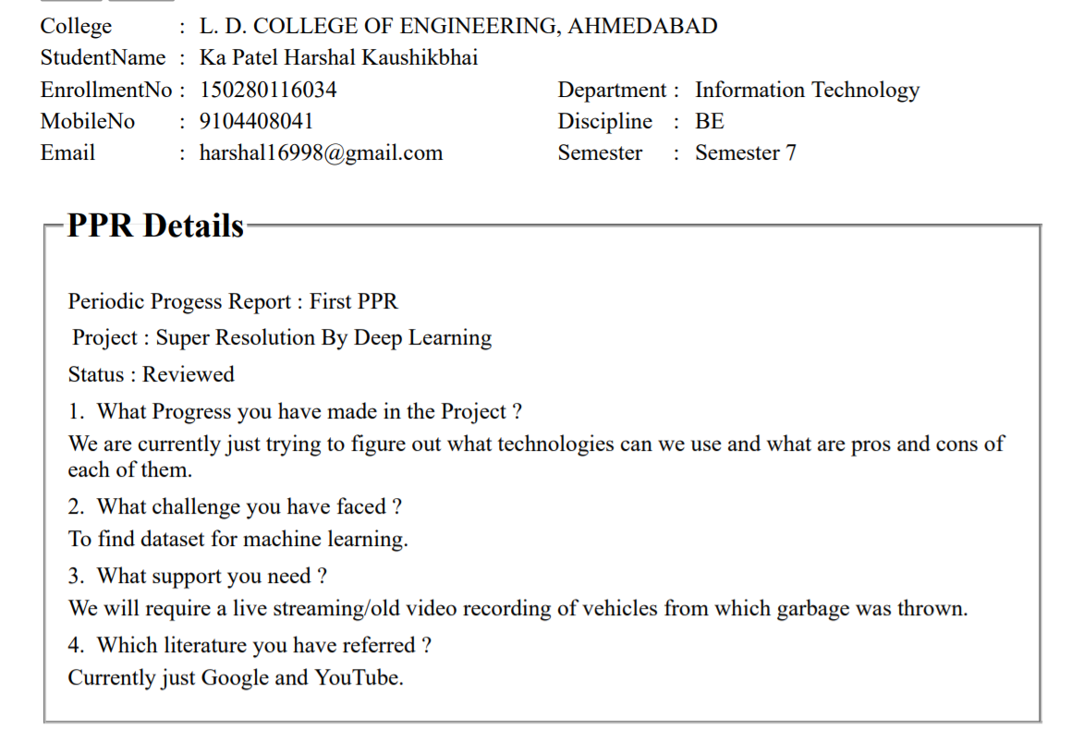

# Periodic Progress Report (2 to 4)

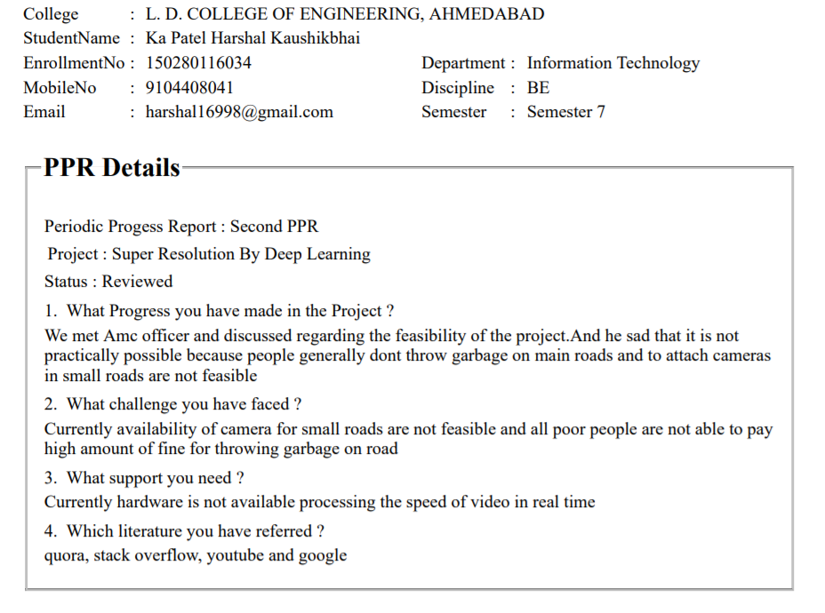

# Periodic Progress Report (3 to 4)

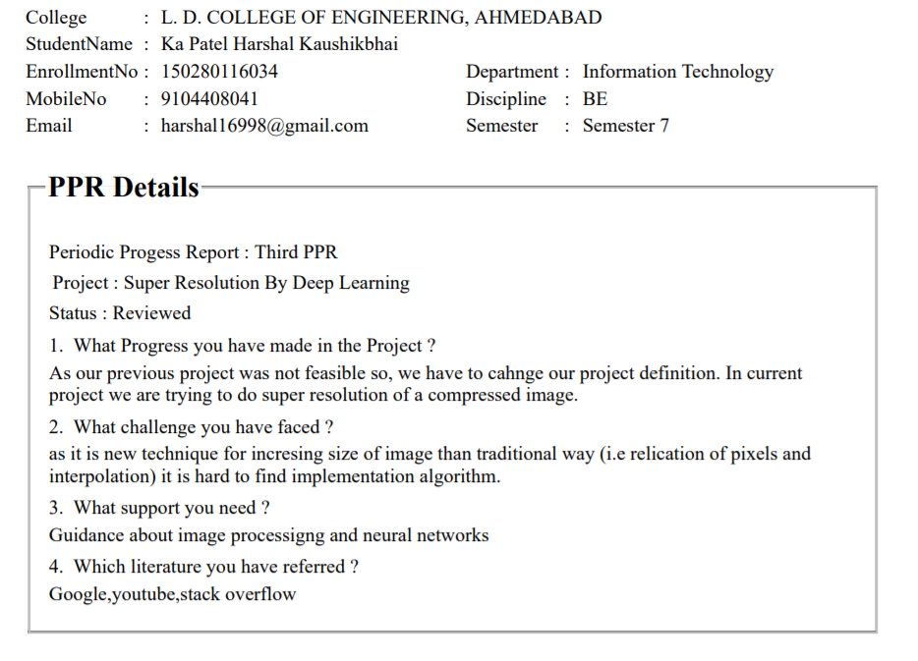

# Periodic Progress Report (4 to 4)

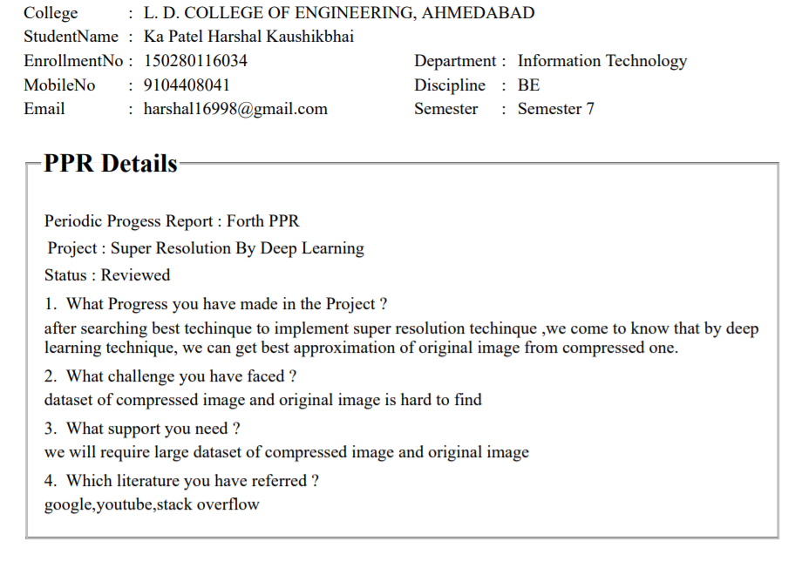

PSAR Report(1 of 5):

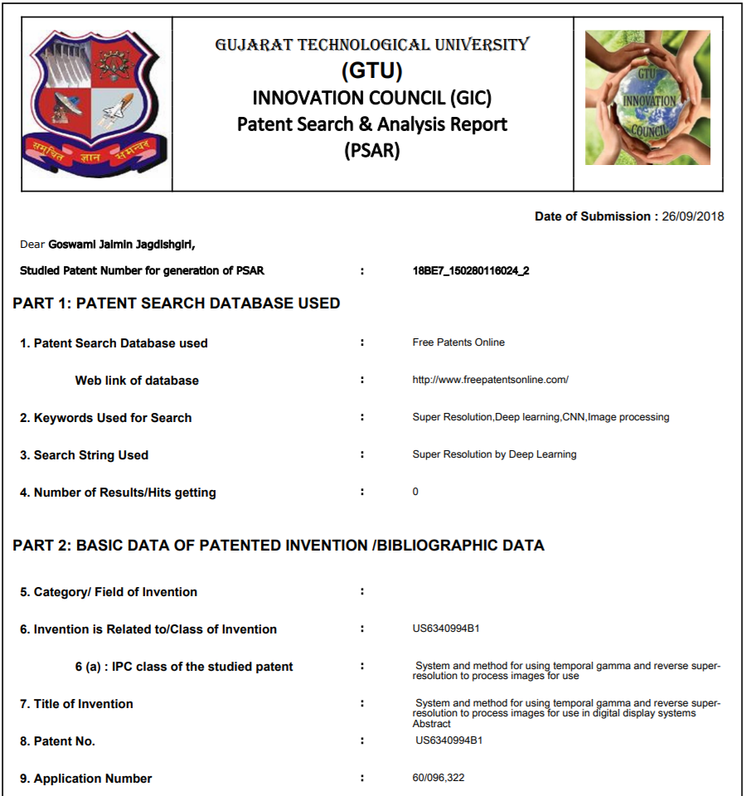

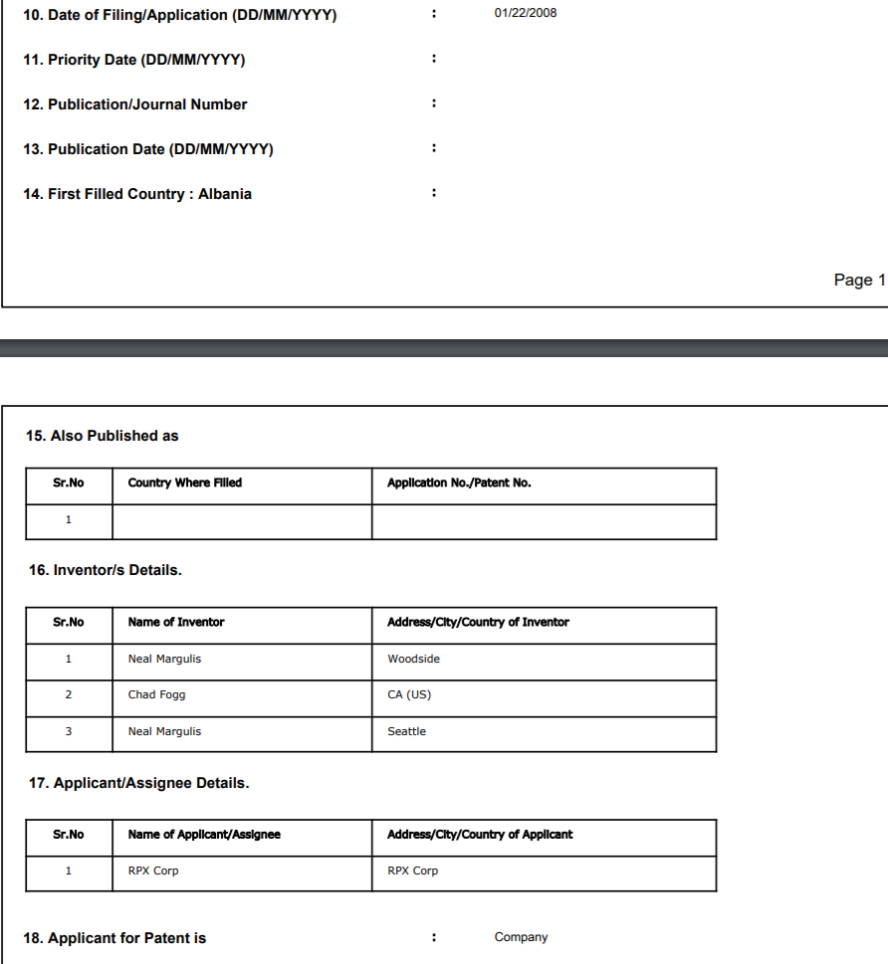



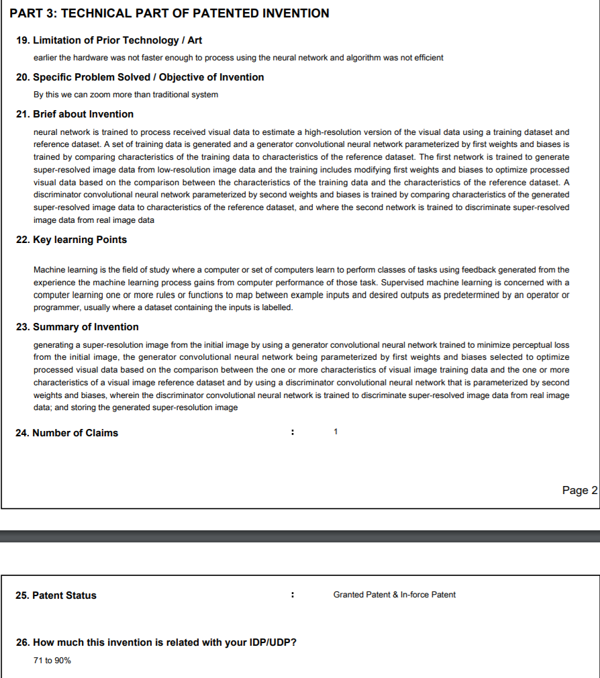



PSAR Report(2 of 5):

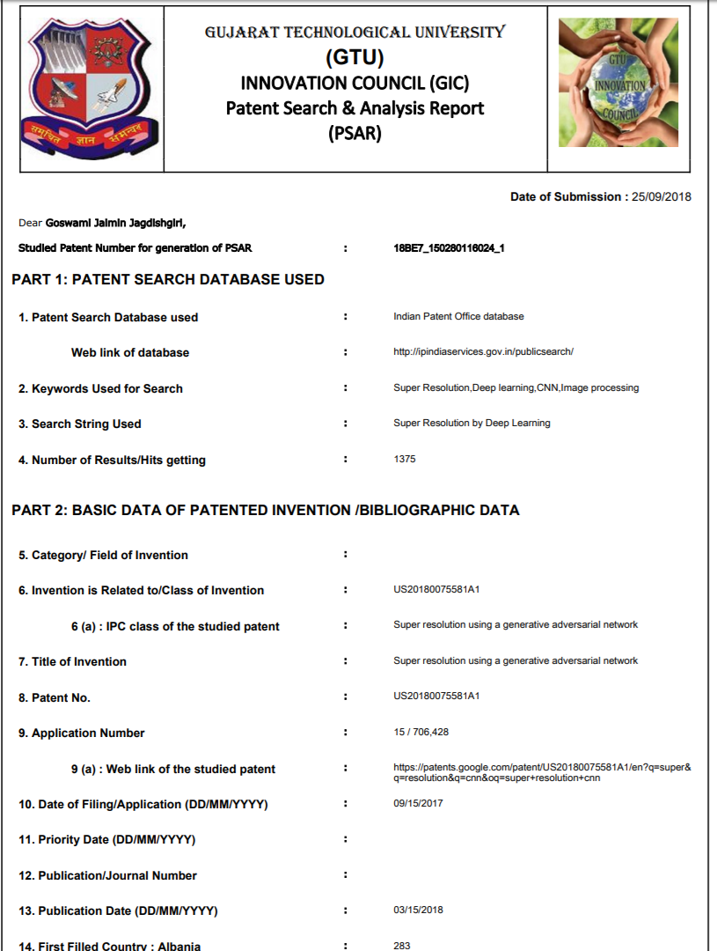

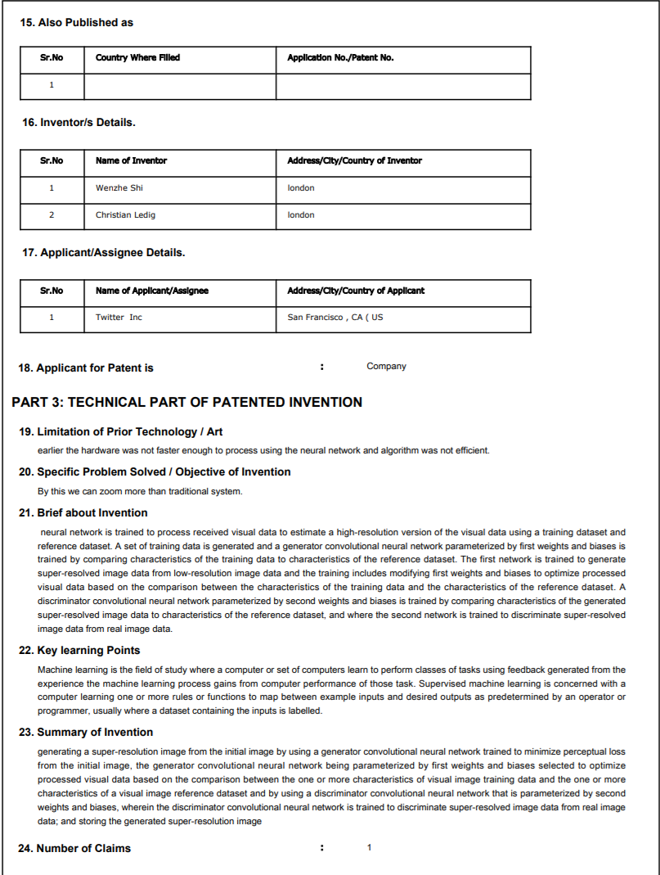



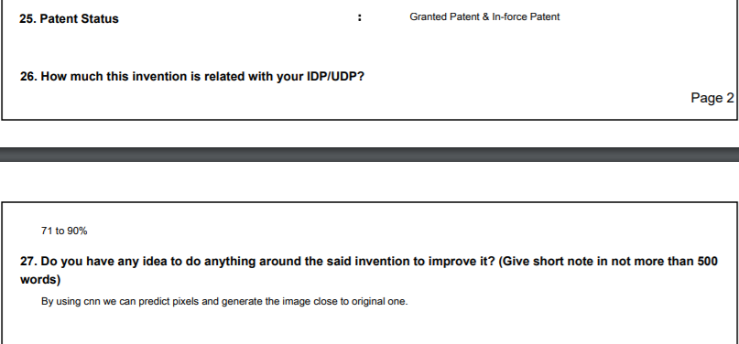

PSAR Report(3 of 5):

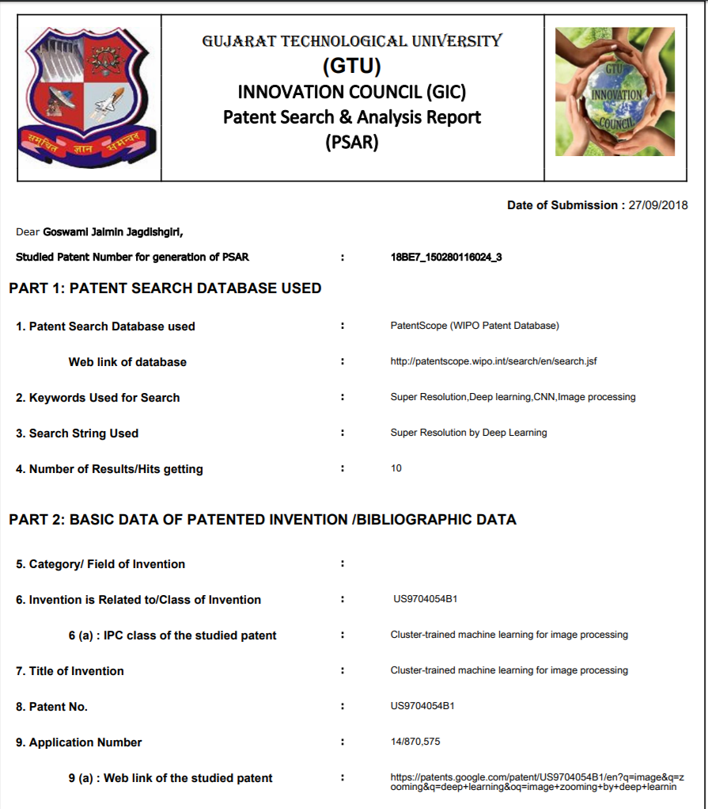

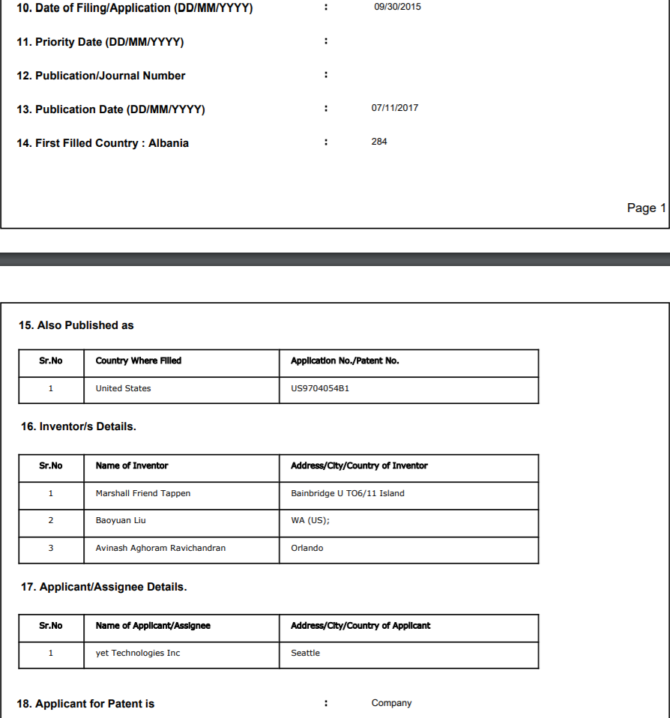

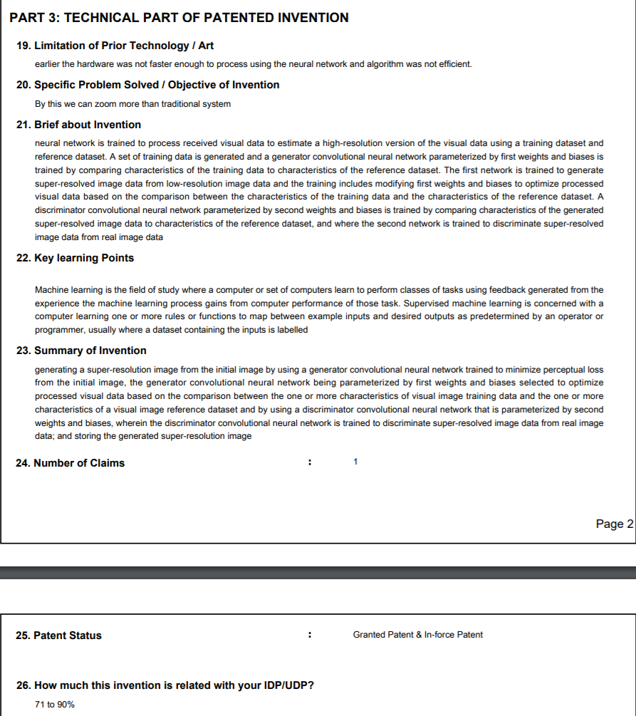

PSAR Report (4 of 5):

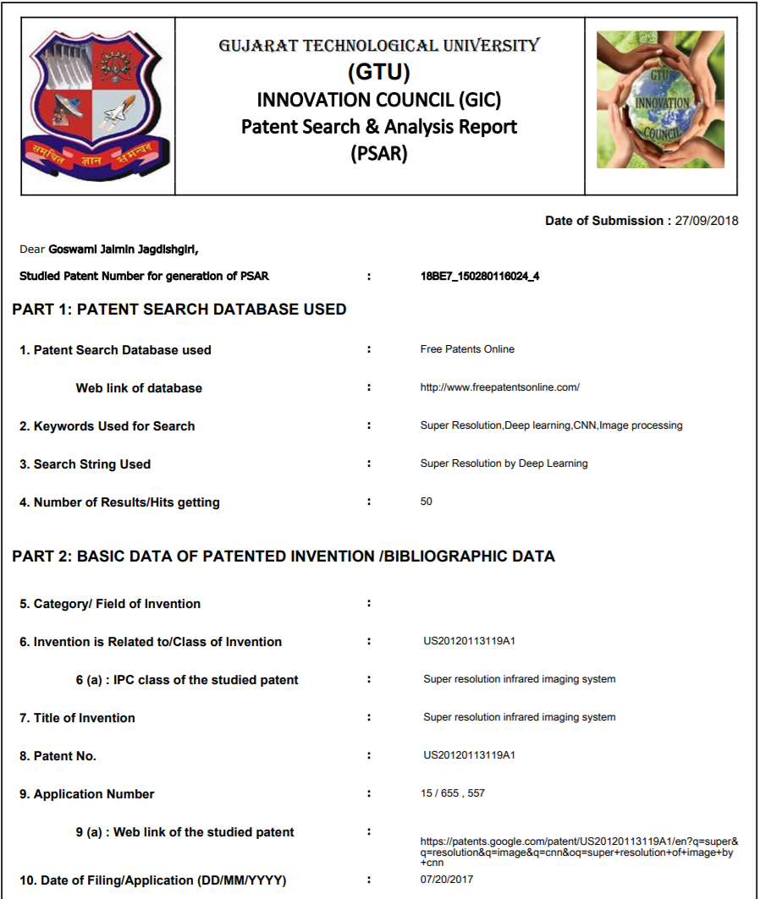

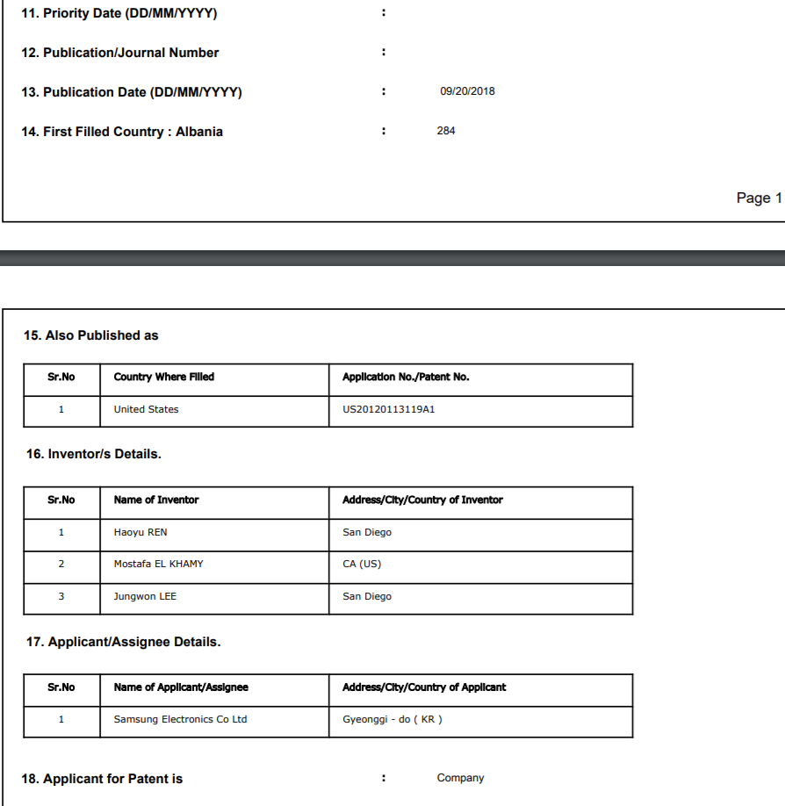

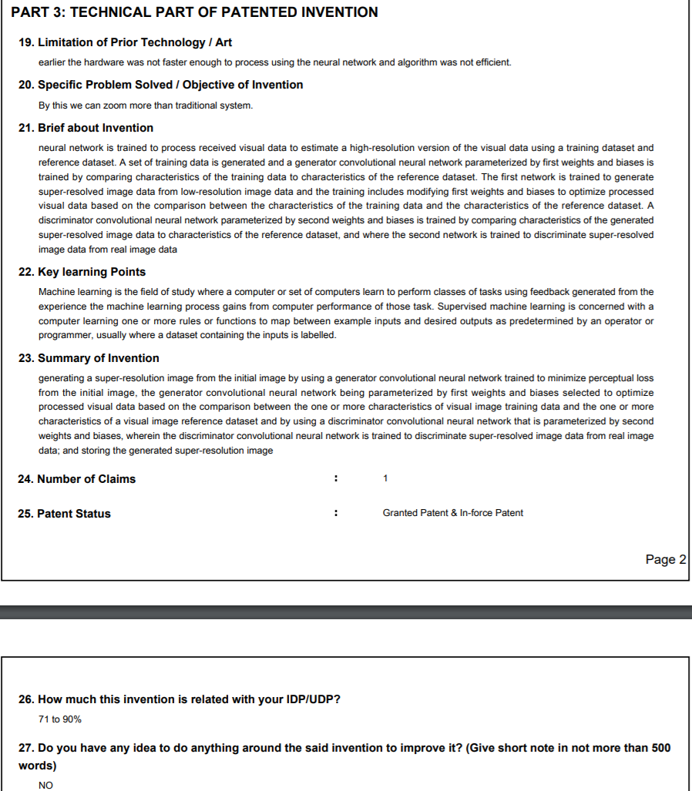

PSAR Report( 5 of 5):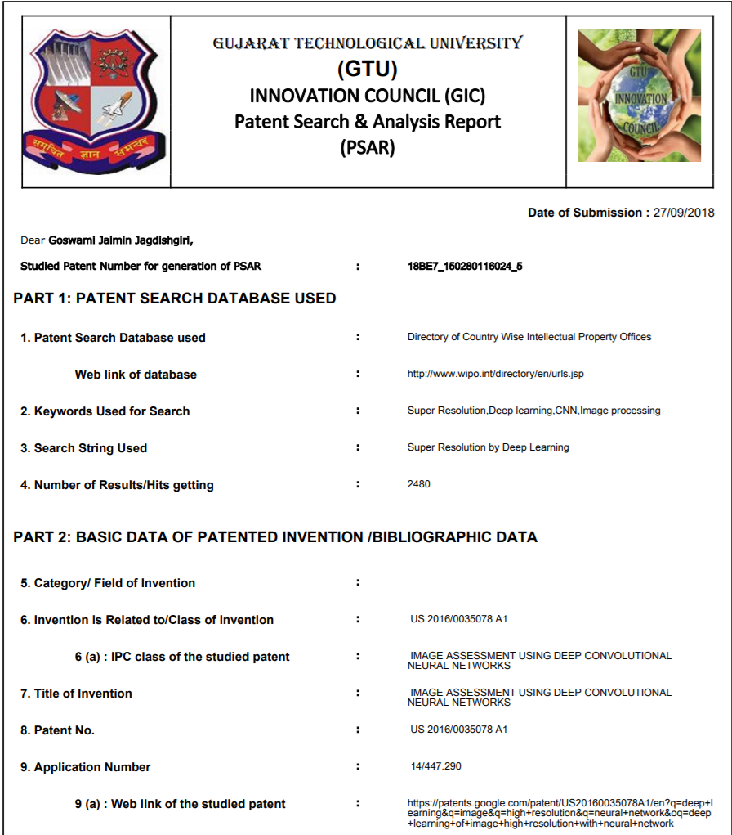

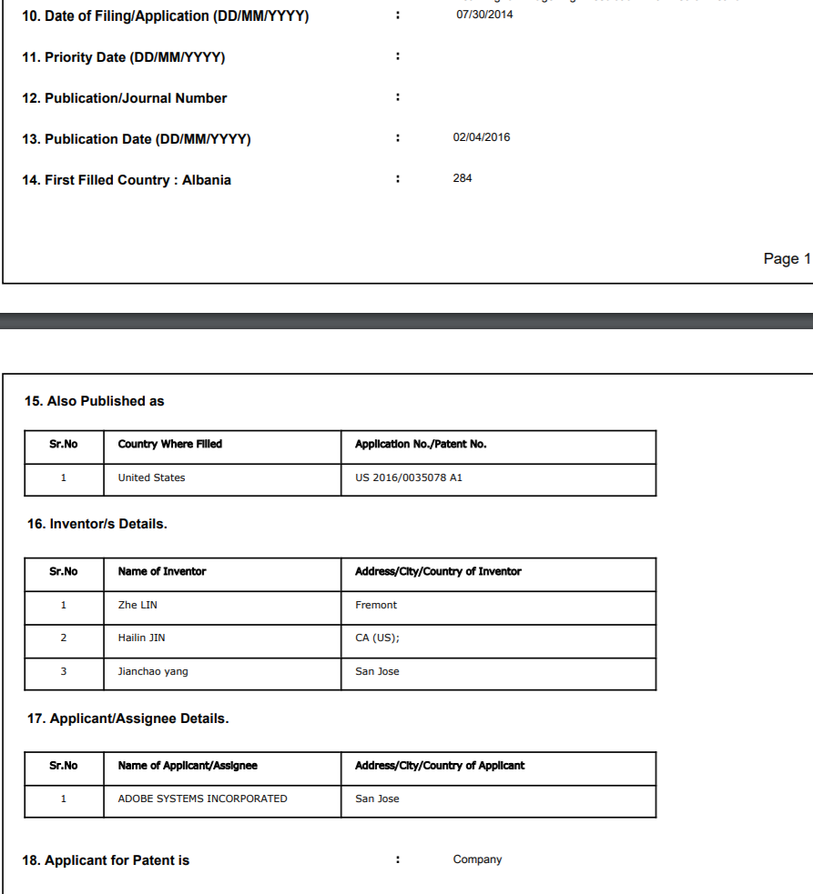

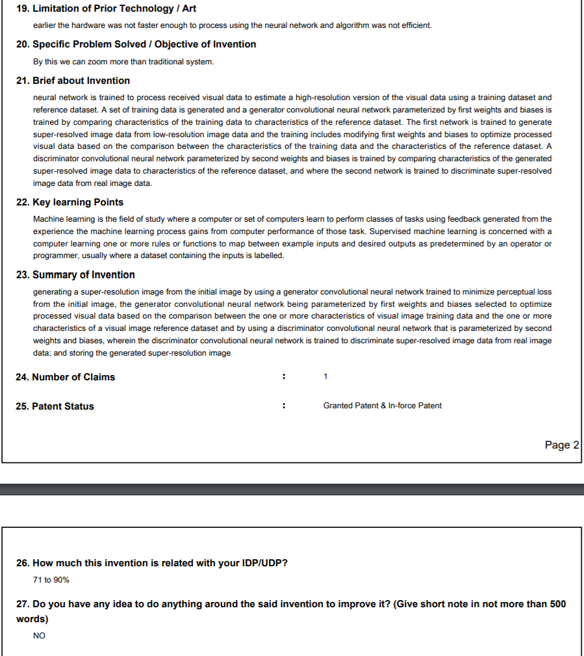

**Patent Drafting Exercise**

|  |  |  |  |  |  |  |  |  |
| --- | --- | --- | --- | --- | --- | --- | --- | --- |
| **FORM 1**  **THE PATENTS ACT 1970**  **(39 OF 1970)**  **&**  **The Patents Rules, 2003**  **APPLICATION FOR GRANT OF PATENT**  **(See section 7,54 & 135 and rule 20 (1))** | | | **(FOR OFFICE USE ONLY)**    **Application No.:**  **Filing Date:**  **Amount of Fee Paid:**  **CBR No.:**  **Signature:** | | | | | |
| **1. APPLICANT** | | | | | | | | |
| Name | | Nationality | | | | | Address | |
| **Indian Institute of Technology,**  **Bombay** | | Indian | | | | | **Indian Institute of Technology,**  **Powai,**  **Mumbai 400076, India** | |
|  | |  | | | | |  | |
|  | |  | | | | |  | |
| **2. INVENTOR ( S )** | | | | | | | | |
| Name | | Nationality | | | | | Address | |
| **Inventor’s name** | | Indian | | | | | **Permanent Address** | |
|  | | Indian | | | | |  | |
|  | |  | | | | |  | |
|  | |  | | | | |  | |
| **3. TITLE OF THE INVENTION** **Title to be added** | | | | | | | | |
| **4. ADDRESS FOR CORRESPONDENCE OF APPLICANT /**  **AUTHORIZED PATENT AGENT IN INDIA**    **Dr Prabuddha Ganguli, 103 B Senate, Lokhandwala**  **Township, Akurli Road, Kandivli East, Mumbai 400101, India** | | | | | | Telephone No. : 91-22-28873766  Fax No. 91-22-28844782  Mobile No. 9820352815  E-mail : ramugang@vsnl.com | | |
| **5. PRIORITY PARTICULARS OF THE APPLICATION (S) FILED IN CONVENTION COUNTRY** | | | | | | | | |
| Country | Application  Number | Filing Date | | Name of the Applicant | | | | Title of the Invention |
| N.A. |  |  | |  | | | |  |
| **6. PARTICULARS FOR FILING PATENT COOPERATION TREATY (PCT) NATIONAL PHASE** | | | | | | | | |
| International application number | | | | | N.A. | | | |
| **9. DECLARATIONS :** | | | | | | | | |
| **(i) Declaration by the Inventor (s)**  We, the above named inventor(s) are the true & first inventor(s) for this invention and declare that the applicant(s) herein is our assignee.   1. Date 2. Signature (s) **Signature** 3. Name(s) **Inventor’s name** | | | | | | | | |
| 1. Date 2. Signature (s) **Signature** 3. Name(s) **Inventor’s name** | | | | | | | | |
| **(ii) Declaration by the applicant (s) in the convention country**  I/We, the applicant(s) in the convention country declare that the applicant(s) herein is our assignee   1. Date 2. Signature (s**) N.A.** 3. Name(s) of the signatory | | | | | | | | |
| 1. Date 2. Signature (s) **N.A.** | | | | | | | | |

(c) Name(s) of the signatory)

|  |
| --- |
| **(iii) Declaration by the applicant (s):**  **I/We, the applicant(s) hereby declare(s) that:** o We are in possession of the above – mentioned invention. o The provisional/complete specification relating to the invention is filed with this application. o The invention as disclosed in the specification uses the biological material from India and the necessary permission from the competent authority shall be submitted by me/us before the grant of patent to me/us.   * There is no lawful ground of objection to the grant of the Patent to me/us. o I am/We are the assignee or legal representative of true & first inventors. * The application or each of the applications, particulars of which are given in Para – 5 was first application in convention country/countries in respect of my/our invention. * I/We claim the priority from the above mentioned application(s) filed in convention country/countries and state that no application for protection in respect of the invention had been made in a convention country before that date by me/us or by any person from which I/We derive the title. * My/our application in India is based on international application under Patent Cooperation Treaty (PCT) as mentioned in Para – 6. * The application is divided out of my/our application particulars of which are given in Para – 7 and pray that this application may be treated as deemed to have been filed on ____________ under sec. 16 of the Act. * The said invention is an improvement in or modification of the invention particulars of which are given in Para – 8 |
| **10. Following are the attachments with the application:**   1. Complete specification. 2. Complete specification (in conformation with the international application) / as amended before the International Preliminary Examination Authority (IPEA), as applicable (2 copies ).   No. of pages 263 No. of claims 215   1. Drawings (in conformation with the international application) / as amended before the International Preliminary Examination Authority (IPEA), as applicable (2 copies). No. of sheets 11 2. Priority documents 3. Translation of priority document / specification/ International Search Report 4. Statement and undertaking on Form 3 5. Power of Authority 6. Declaration of inventorship on Form 5 7. Sequence listing in electronic form (floppy disc) 8. ………………………………   Fee Rs. ………………………in Cash/Cheque/Bank Draft bearing no. ……………….. Date ………. On ……….. Bank.  I/We hereby declare that to the best of my/our knowledge, information and belief the fact and matters stated herein are correct and I/We request that a patent may be granted to me/us for the said invention.    Dated this day of September 2005.    Signature :-  Name :  To,  The Controller of Patent  The Patent Office, at Mumbai |

**FORM 3**

**THE PATENT ACT, 1970**

**( 39 OF 1970 )**

**&**

**The Patents Rules, 2003**

**STATEMENT AND UNDERTAKING UNDER SECTION 8**

**( See section 8, rule 12 )**

We INDIAN INSTITUTE OF TECHNOLOGY, BOMBAY hereby declare

(i) that /We who have made this application No. **1267/MUM/2004** Dated **25 November 2004** alone, made for the same/substantially same invention, application(s) for patent in the other countries, the particulars of which are given below :

Name of the Date of Application No. Status of the Date of Date of grant country Application application publication

Not Applicable

(iii) that the rights in the application(s) have been assigned to us and that We undertake that upto the date of grant of the patent, by the Controller. We would keep him informed in writing the details regarding corresponding applications for patents filed outside India within three months from the date of filing of such application.

Dated this day of September 2005

For **INDIAN INSTITUTE OF TECHNOLOGY BOMBAY**

To,

The Controller of Patent

**The Patent Office, Mumbai**

## F O R M 2

**THE PATENTS ACT, 1970**

**(39 of 1970)**

PROVISIONAL / COMPLETE SPECIFICATION

**(See section 10 and rule 13)**

|  |  |
| --- | --- |
| 1. TITLE OF THE INVENTION | |
| **2. APPLICANT(S)**   1. **NAME** 2. **NATIONALITY** 3. **ADDRESS** | |
| **3. PREAMBLE TO THE DESCRITION** | |
| **PROVISIONAL**  The following specification describes invention | **COMPLETE**  The following specification particularly describes the invention and the manner in which it is to be performed |
| **4. DESCRIPTION** (Description shall start from next page) | |
| **5. CLAIMS** (not applicable for provisional specification. Claims should start with the preamble – “I/We claim” on separate page) | |
| **6. DATE AND SIGNATURE** ( to be given on the last page of specification) | |
| **7. ABSTRACT OF THE INVENTION (to be given along with complete specification on the separate page)** | |
| **Note:**  *Repeat boxes in case of more than one entry  *To be signed by the applicant(s)or the authorized registered patent agent  *Name of the applicant should be given in full, family name in the beginning  *Complete address of the applicant should be given stating with postal index no. / code, state and country *Strike out the column which is/are not applicable | |

**Plagiarism Report**

**82% Unique**

**Total 41388 chars (**[**2000 limit exceeded**](https://plagiarisma.net/payment.php)**) , 310 words, 11 unique sentence(s).**

[**Essay Writing Service**](https://plagiarisma.net/essay-writing-service.php) **- *Paper writing service you can trust. Your assignment is our priority! Papers ready in 3 hours! Proficient writing: top academic writers at your service 24/7! Receive a premium level paper!***

|  |  |  |  |  |  |  |  |  |  |  |  |  |  |  |  |  |  |  |  |  |  |  |  |  |  |  |  |  |  |  |  |  |  |  |  |  |  |  |  |  |  |  |  |  |  |  |  |
| --- | --- | --- | --- | --- | --- | --- | --- | --- | --- | --- | --- | --- | --- | --- | --- | --- | --- | --- | --- | --- | --- | --- | --- | --- | --- | --- | --- | --- | --- | --- | --- | --- | --- | --- | --- | --- | --- | --- | --- | --- | --- | --- | --- | --- | --- | --- | --- |
| |  | | --- | | Results | | Unique | | 1 results | | Unique | | Unique | | Unique | | Unique | | Unique | | Unique | | Unique | | Unique | | 1 results | | 1 results | | Unique | | Unique | | |  | | --- | | Query | | [This metric is a defacto standard used in Super Resolution research](https://www.bing.com/search?q=%2B%5B%22This+metric+is%C2%A0a%C2%A0defacto+standard+used+in%C2%A0Super+Resolution+research%22%5D&qs=n&form=QBLH&sp=-1&pq=%2B%5B%22This+metric+is%C2%A0a%C2%A0defacto+standard+used+in%C2%A0Super+Resolution+research%22%5D&sc=8-5&sk=&setlang=en&adlt=off&cvid=10E8F9FD39ED008E04DF130192C9C5E9) | | [That was our approach in two out of three models we present here](https://www.bing.com/search?q=%2B%5B%22That+was%C2%A0our%C2%A0approach+in%C2%A0two%C2%A0out%C2%A0of%C2%A0three+models+we%C2%A0present+here%22%5D&qs=n&form=QBLH&sp=-1&pq=%2B%5B%22That+was%C2%A0our%C2%A0approach+in%C2%A0two%C2%A0out%C2%A0of%C2%A0three+models+we%C2%A0present+here%22%5D&sc=8-5&sk=&setlang=en&adlt=off&cvid=592C7A792A2C8DDB8EFA2105C7080D53) | | [In our experiments, we trained the models to upscale input i](https://www.bing.com/search?q=%2B%5B%22In%C2%A0our%C2%A0experiments%2C+we%C2%A0trained+the%C2%A0models+to%C2%A0upscale+input+im%22%5D&qs=n&form=QBLH&sp=-1&pq=%2B%5B%22In%C2%A0our%C2%A0experiments%2C+we%C2%A0trained+the%C2%A0models+to%C2%A0upscale+input+im%22%5D&sc=8-5&sk=&setlang=en&adlt=off&cvid=DA587DC982EFA637501E787BB26F029C)n | | [Abstract :Single Image Super Resolution involves increasing the size of a small image while keeping](https://www.bing.com/search?q=%2B%5B%22Abstract+%3ASingle+Image+Super+Resolution+involves+increasing+the+size+of+a+small+image+while+keeping%22%5D&qs=n&form=QBLH&sp=-1&pq=%2B%5B%22Abstract+%3ASingle+Image+Super+Resolution+involves+increasing+the+size+of+a+small+image+while+keeping%22%5D&sc=8-5&sk=&setlang=en&adlt=off&cvid=229F77B0273A624E52756723FD951CA1) | | [processing, compressed image/video enhancement and many more.1.1 PROJECT DETAIL Our objective is to take](https://www.bing.com/search?q=%2B%5B%22processing%2C+compressed+image%2Fvideo+enhancement+and+many+more.1.1+PROJECT+DETAIL+Our+objective+is+to+take%22%5D&qs=n&form=QBLH&sp=-1&pq=%2B%5B%22processing%2C+compressed+image%2Fvideo+enhancement+and+many+more.1.1+PROJECT+DETAIL+Our+objective+is+to+take%22%5D&sc=8-5&sk=&setlang=en&adlt=off&cvid=BED82D953FC16A07FF5111EC942CC6C6) | | [This problem is illposed – multiple highresolution images can be produced from the same](https://www.bing.com/search?q=%2B%5B%22This+problem+is+illposed+%E2%80%93+multiple+highresolution+images+can+be+produced+from+the+same%22%5D&qs=n&form=QBLH&sp=-1&pq=%2B%5B%22This+problem+is+illposed+%E2%80%93+multiple+highresolution+images+can+be+produced+from+the+same%22%5D&sc=8-5&sk=&setlang=en&adlt=off&cvid=5C5B45F7B0212D7852773FE18532FCCE) | | [For instance, suppose we have a 2×2 pixel subimage containing a small vertical or](https://www.bing.com/search?q=%2B%5B%22For+instance%2C+suppose+we+have+a+2%C3%972+pixel+subimage+containing+a+small+vertical+or%22%5D&qs=n&form=QBLH&sp=-1&pq=%2B%5B%22For+instance%2C+suppose+we+have+a+2%C3%972+pixel+subimage+containing+a+small+vertical+or%22%5D&sc=8-5&sk=&setlang=en&adlt=off&cvid=A100E7784F0CDF6031BFC8E0BBA52E8B) | | [Regardless of the orientation of the bar, these 4 pixels will correspond to just](https://www.bing.com/search?q=%2B%5B%22Regardless+of+the+orientation+of+the+bar%2C+these+4+pixels+will+correspond+to+just%22%5D&qs=n&form=QBLH&sp=-1&pq=%2B%5B%22Regardless+of+the+orientation+of+the+bar%2C+these+4+pixels+will+correspond+to+just%22%5D&sc=8-5&sk=&setlang=en&adlt=off&cvid=0C0FCF03BF103B1DD8C8F7DF2BEBB3EE) | | [With real life images, one needs to overcome an abundance of similar problems, making](https://www.bing.com/search?q=%2B%5B%22With+real+life+images%2C+one+needs+to+overcome+an+abundance+of+similar+problems%2C+making%22%5D&qs=n&form=QBLH&sp=-1&pq=%2B%5B%22With+real+life+images%2C+one+needs+to+overcome+an+abundance+of+similar+problems%2C+making%22%5D&sc=8-5&sk=&setlang=en&adlt=off&cvid=B6E7F6FDE7686C08421E67C47FF60933) | | [a model trained to minimize MSE loss First, let’s introduce a quantitative quality measurement method to evaluate](https://www.bing.com/search?q=%2B%5B%22a+model+trained+to+minimize+MSE+lossFirst%2C+let%E2%80%99s+introduce+a+quantitative+qualitymeasurement+method+to+evaluate%22%5D&qs=n&form=QBLH&sp=-1&pq=%2B%5B%22a+model+trained+to+minimize+MSE+lossFirst%2C+let%E2%80%99s+introduce+a+quantitative+qualitymeasurement+method+to+evaluate%22%5D&sc=8-5&sk=&setlang=en&adlt=off&cvid=6F5DA1119A353397D752E54CCAAFD507) | | [For each model implemented, we will compute a metric commonly used to measure the](https://www.bing.com/search?q=%2B%5B%22For+each+model+implemented%2C+we+will+compute+a+metric+commonly+used+to+measure+the%22%5D&qs=n&form=QBLH&sp=-1&pq=%2B%5B%22For+each+model+implemented%2C+we+will+compute+a+metric+commonly+used+to+measure+the%22%5D&sc=8-5&sk=&setlang=en&adlt=off&cvid=C1C6548CD5EBEEFCC408B35AB3CC2DEE) | | [It measures how much the distorted image (possibly of lower quality) deviates from the](https://www.bing.com/search?q=%2B%5B%22It+measures+how+much+the+distorted+image+%28possibly+of+lower+quality%29+deviates+from+the%22%5D&qs=n&form=QBLH&sp=-1&pq=%2B%5B%22It+measures+how+much+the+distorted+image+%28possibly+of+lower+quality%29+deviates+from+the%22%5D&sc=8-5&sk=&setlang=en&adlt=off&cvid=323BA31D91BDFDB914422AD4E3DD1848) | | [image (signal strength) to maximum mean squared error (MSE) between the original image and its](https://www.bing.com/search?q=%2B%5B%22image+%28signal+strength%29+to+maximum+mean+squared+error+%28MSE%29+between+the+original+image+and+its%22%5D&qs=n&form=QBLH&sp=-1&pq=%2B%5B%22image+%28signal+strength%29+to+maximum+mean+squared+error+%28MSE%29+between+the+original+image+and+its%22%5D&sc=8-5&sk=&setlang=en&adlt=off&cvid=FCD85F17D8B1F8486D663BA15FD5DE0B) | | [The larger the PSNR values, the better the reconstruction, and therefore maximization of PSNR naturally](https://www.bing.com/search?q=%2B%5B%22The+larger+the+PSNR+values%2C+the+better+the+reconstruction%2C+and+therefore+maximization+of+PSNR+naturally%22%5D&qs=n&form=QBLH&sp=-1&pq=%2B%5B%22The+larger+the+PSNR+values%2C+the+better+the+reconstruction%2C+and+therefore+maximization+of+PSNR+naturally%22%5D&sc=8-5&sk=&setlang=en&adlt=off&cvid=4FA95422F35D8E76D3935E2C7379F6D0) | | |  | | --- | | Domains (original links) | | - | | [deepsense.ai](https://deepsense.ai/using-deep-learning-for-single-image-super-resolution/) | | - | | - | | - | | - | | - | | - | | - | | - | | [deepsense.ai](https://deepsense.ai/using-deep-learning-for-single-image-super-resolution/) | | [deepsense.ai](https://deepsense.ai/using-deep-learning-for-single-image-super-resolution/) | | - | | - | |

Top plagiarizing domains: **deepsense.ai (3 matches);**

**Abstract :**

Single Image Super Resolution involves increasing the size of a small image while keeping the attendant drop in quality to a minimum. The task has numerous applications, including in satellite and aerial imaging analysis, medical image processing, compressed image/video enhancement and many more.1.1 PROJECT DETAIL Our objective is to take a low resolution image and produce an estimate of a corresponding high-resolution image. This problem is illposed – multiple high-resolution images can be produced from the same low resolution image. For instance, suppose we have a 2×2 pixel subimage containing a small vertical or horizontal bar [Fig. 1]. Regardless of the orientation of the bar, these 4 pixels will correspond to just one pixel in a picture downscaled 4 times. With real life images, one needs to overcome an abundance of similar problems, making the task difficult to solve.

Figure 1: from left to right, ground truth HR image, corresponding LR image, prediction of a model trained to minimize MSE lossFirst, let’s introduce a quantitative quality measurement method to evaluate and compare the models. For each model implemented, we will compute a metric commonly used to measure the quality of reconstruction of lossy compression codecs, called Peak Signal to Noise Ratio (PSNR). This metric is a defacto standard used in Super Resolution research. It measures how much the distorted image (possibly of lower quality) deviates from the original highquality image. In this setting, PSNR is the ratio of maximum possible pixel value of the image (signal strength) to maximum mean squared error (MSE) between the original image and its estimated version (noise strength), expressed in logarithmic scale. The larger the PSNR values, the better the reconstruction, and therefore maximization of PSNR naturally leads to minimizing MSE as the objective function. That was our approach in two out of three models we present here. In our experiments, we trained the models to upscale input image.

**Design Engineering Canvass**

Empathy Canvas:

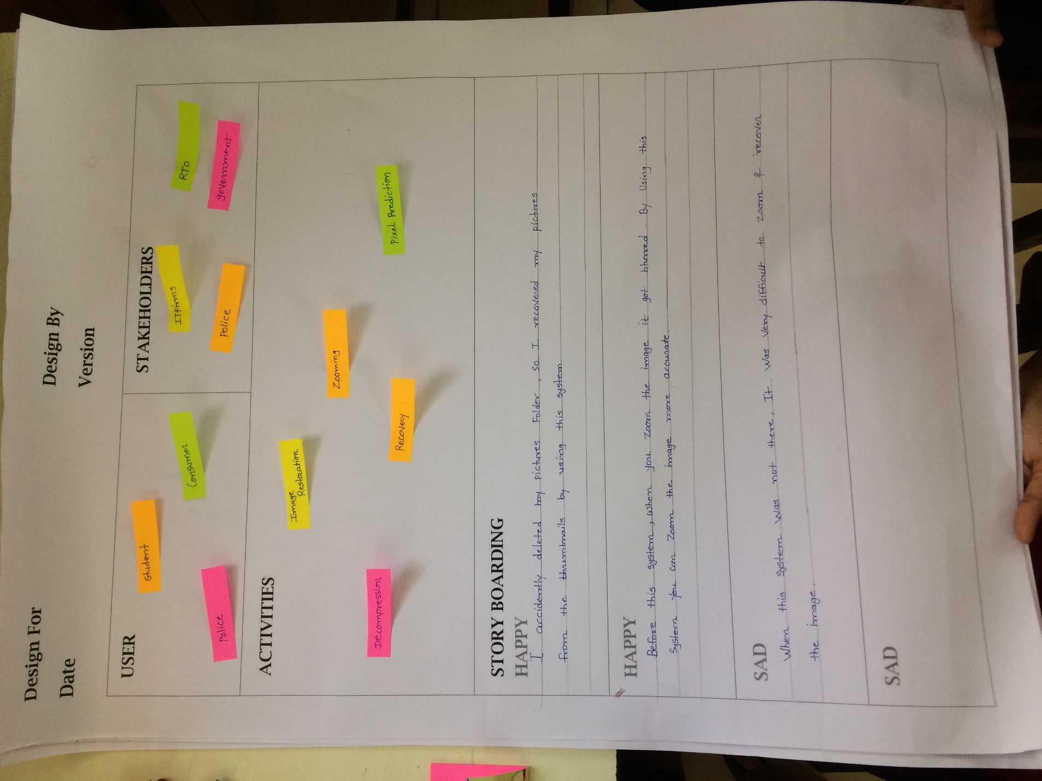

AEIOU Canvas:

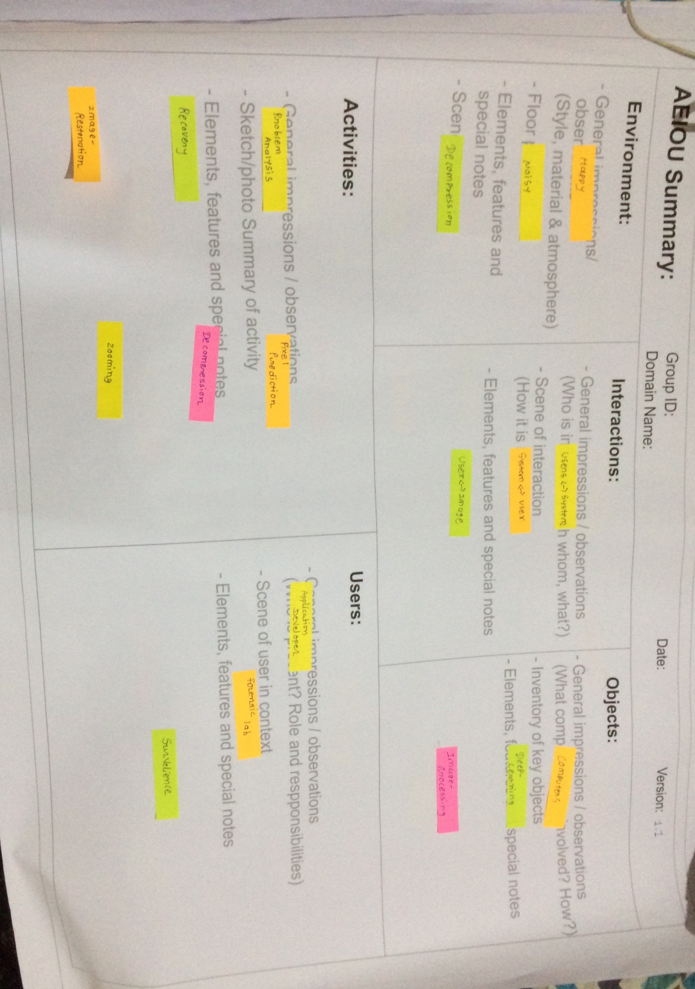

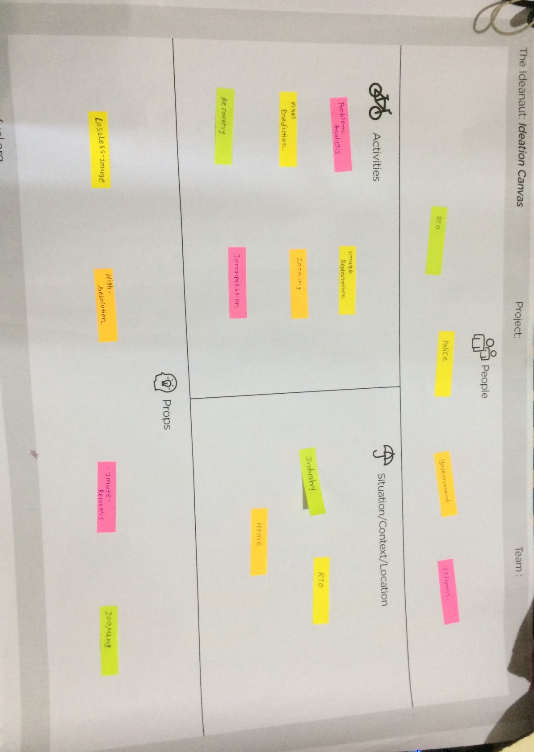Ideation Canvas:

Product Development Canvas:

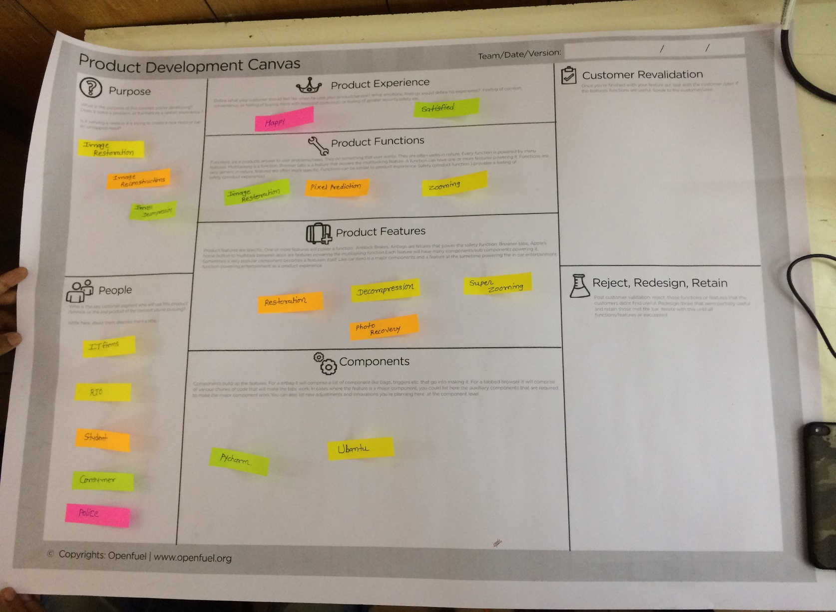

|  |  |  |  |  |  |  |  |  |
| --- | --- | --- | --- | --- | --- | --- | --- | --- |
| **FORM 1**  **THE PATENTS ACT 1970**  **(39 OF 1970)**  **&**  **The Patents Rules, 2003**  **APPLICATION FOR GRANT OF PATENT**  **(See section 7,54 & 135 and rule 20 (1))** | | | **(FOR OFFICE USE ONLY)**    **Application No.:**  **Filing Date:**  **Amount of Fee Paid:**  **CBR No.:**  **Signature:** | | | | | |
| **1. APPLICANT** | | | | | | | | |
| Name | | Nationality | | | | | Address | |
| **Indian Institute of Technology,**  **Bombay** | | Indian | | | | | **Indian Institute of Technology,**  **Powai,**  **Mumbai 400076, India** | |
|  | |  | | | | |  | |
|  | |  | | | | |  | |
| **2. INVENTOR ( S )** | | | | | | | | |
| Name | | Nationality | | | | | Address | |
| **Inventor’s name** | | Indian | | | | | **Permanent Address** | |
|  | | Indian | | | | |  | |
|  | |  | | | | |  | |
|  | |  | | | | |  | |
| **3. TITLE OF THE INVENTION** **Title to be added** | | | | | | | | |
| **4. ADDRESS FOR CORRESPONDENCE OF APPLICANT /**  **AUTHORIZED PATENT AGENT IN INDIA**    **Dr Prabuddha Ganguli, 103 B Senate, Lokhandwala**  **Township, Akurli Road, Kandivli East, Mumbai 400101, India** | | | | | | Telephone No. : 91-22-28873766  Fax No. 91-22-28844782  Mobile No. 9820352815  E-mail : ramugang@vsnl.com | | |
| **5. PRIORITY PARTICULARS OF THE APPLICATION (S) FILED IN CONVENTION COUNTRY** | | | | | | | | |
| Country | Application  Number | Filing Date | | Name of the Applicant | | | | Title of the Invention |
| N.A. |  |  | |  | | | |  |
| **6. PARTICULARS FOR FILING PATENT COOPERATION TREATY (PCT) NATIONAL PHASE** | | | | | | | | |
| International application number | | | | | N.A. | | | |
| **9. DECLARATIONS :** | | | | | | | | |
| **(i) Declaration by the Inventor (s)**  We, the above named inventor(s) are the true & first inventor(s) for this invention and declare that the applicant(s) herein is our assignee.   1. Date 2. Signature (s) **Signature** 3. Name(s) **Inventor’s name** | | | | | | | | |
| 1. Date 2. Signature (s) **Signature** 3. Name(s) **Inventor’s name** | | | | | | | | |
| **(ii) Declaration by the applicant (s) in the convention country**  I/We, the applicant(s) in the convention country declare that the applicant(s) herein is our assignee   1. Date 2. Signature (s**) N.A.** 3. Name(s) of the signatory | | | | | | | | |
| 1. Date 2. Signature (s) **N.A.** | | | | | | | | |

(c) Name(s) of the signatory)

|  |
| --- |
| **(iii) Declaration by the applicant (s):**  **I/We, the applicant(s) hereby declare(s) that:** o We are in possession of the above – mentioned invention. o The provisional/complete specification relating to the invention is filed with this application. o The invention as disclosed in the specification uses the biological material from India and the necessary permission from the competent authority shall be submitted by me/us before the grant of patent to me/us.   * There is no lawful ground of objection to the grant of the Patent to me/us. o I am/We are the assignee or legal representative of true & first inventors. * The application or each of the applications, particulars of which are given in Para – 5 was first application in convention country/countries in respect of my/our invention. * I/We claim the priority from the above mentioned application(s) filed in convention country/countries and state that no application for protection in respect of the invention had been made in a convention country before that date by me/us or by any person from which I/We derive the title. * My/our application in India is based on international application under Patent Cooperation Treaty (PCT) as mentioned in Para – 6. * The application is divided out of my/our application particulars of which are given in Para – 7 and pray that this application may be treated as deemed to have been filed on ____________ under sec. 16 of the Act. * The said invention is an improvement in or modification of the invention particulars of which are given in Para – 8 |
| **10. Following are the attachments with the application:**   1. Complete specification. 2. Complete specification (in conformation with the international application) / as amended before the International Preliminary Examination Authority (IPEA), as applicable (2 copies ).   No. of pages 263 No. of claims 215   1. Drawings (in conformation with the international application) / as amended before the International Preliminary Examination Authority (IPEA), as applicable (2 copies). No. of sheets 11 2. Priority documents 3. Translation of priority document / specification/ International Search Report 4. Statement and undertaking on Form 3 5. Power of Authority 6. Declaration of inventorship on Form 5 7. Sequence listing in electronic form (floppy disc) 8. ………………………………   Fee Rs. ………………………in Cash/Cheque/Bank Draft bearing no. ……………….. Date ………. On ……….. Bank.  I/We hereby declare that to the best of my/our knowledge, information and belief the fact and matters stated herein are correct and I/We request that a patent may be granted to me/us for the said invention.    Dated this day of September 2005.    Signature :-  Name :  To,  The Controller of Patent  The Patent Office, at Mumbai |

**FORM 3**

**THE PATENT ACT, 1970**

**( 39 OF 1970 )**

**&**

**The Patents Rules, 2003**

**STATEMENT AND UNDERTAKING UNDER SECTION 8**

**( See section 8, rule 12 )**

We INDIAN INSTITUTE OF TECHNOLOGY, BOMBAY hereby declare

(i) that /We who have made this application No. **1267/MUM/2004** Dated **25 November 2004** alone, made for the same/substantially same invention, application(s) for patent in the other countries, the particulars of which are given below :

Name of the Date of Application No. Status of the Date of Date of grant country Application application publication

Not Applicable

(iii) that the rights in the application(s) have been assigned to us and that We undertake that upto the date of grant of the patent, by the Controller. We would keep him informed in writing the details regarding corresponding applications for patents filed outside India within three months from the date of filing of such application.

Dated this day of September 2005

For **INDIAN INSTITUTE OF TECHNOLOGY BOMBAY**

To,

The Controller of Patent

**The Patent Office, Mumbai**